**DAILY ONLINE ACTIVITIES SUMMARY**

|  |  |  |  |  |  |  |  |  |
| --- | --- | --- | --- | --- | --- | --- | --- | --- |
| **Date:** | **02-06-2020** | | | | | **Name:** | **Shetty Disha Ravindra** | |
| **Sem & Sec** | **VI B sec** | | | | | **USN:** | **4a17cs087** | |
| **Online Test Summary** | | | | | | | | |
| **Subject** | | **Computer graphics and visualization** | | | | | | |
| **Max. Marks** | | **30** | | **Score** | | | **30** | |
| **Certification Course Summary** | | | | | | | | |
| **Course** | **Robotic Process Automation** | | | | | | | |
| **Certificate Provider** | | | **GUVI** | | **Duration** | | | **3hrs** |
| **Coding Challenges** | | | | | | | | |
| **Problem Statement:-**1] Python program to return a list containing first and last element using list slicing method | | | | | | | | |
| **Status: executed** | | | | | | | | |
| **Uploaded the report in Github** | | | | | **Yes** | | | |
| **If yes Repository name** | | | | | <https://github.com/alvas-education-foundation/Disha_Shetty> | | | |
| **Uploaded the report in slack** | | | | | **Yes** | | | |

Online Test Details: (Attach the snapshot and briefly write the report for the same)

Certification Course Details: (Attach the snapshot and briefly write the report for the same)

Coding Challenges Details: (Attach the snapshot and briefly write the report for the same)

Online Test

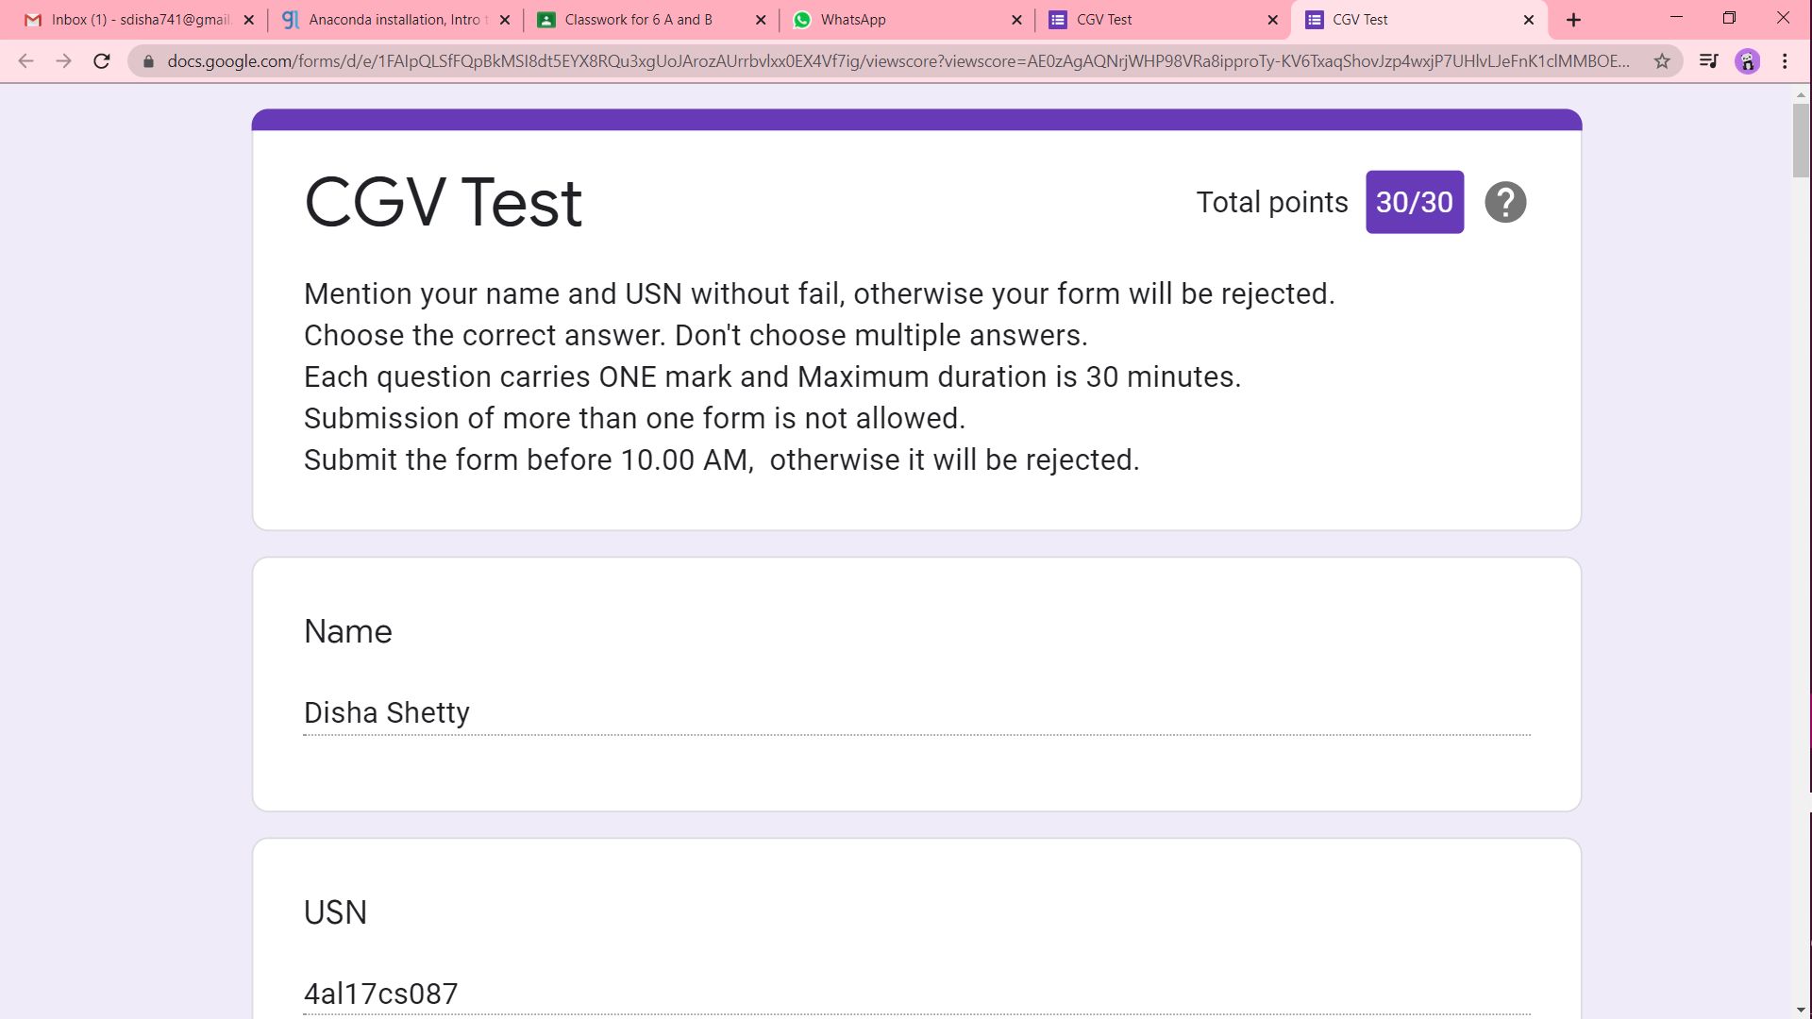

Certification progress

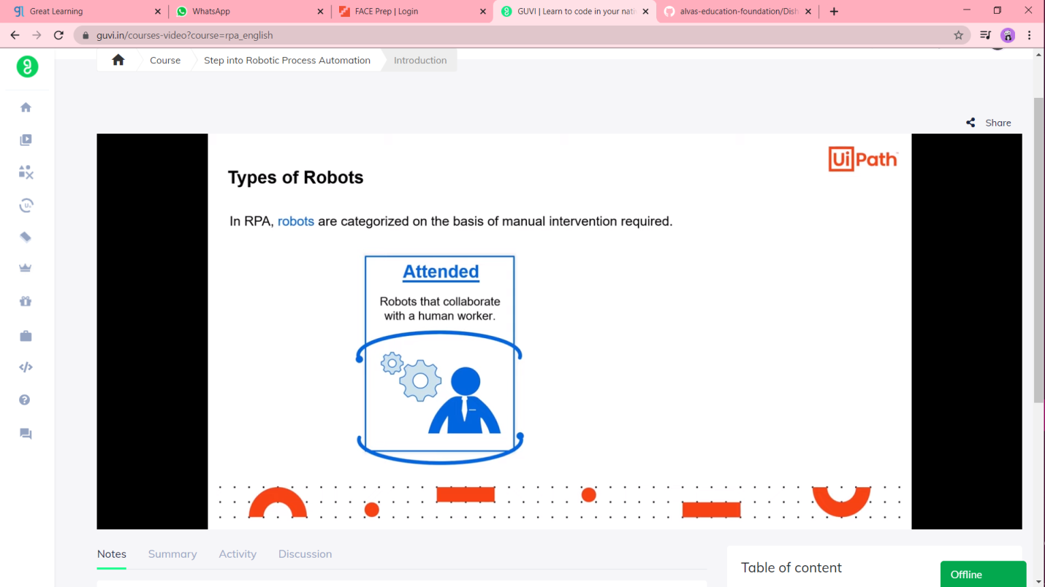

Coding Challenges

1]